Assignment – 2

Build a python code, assume you get temperature and humidity values(generated with the random function to a variable), and write a condition to continuously detect alarm in case of high temperature.

Program and screen shot of execution:

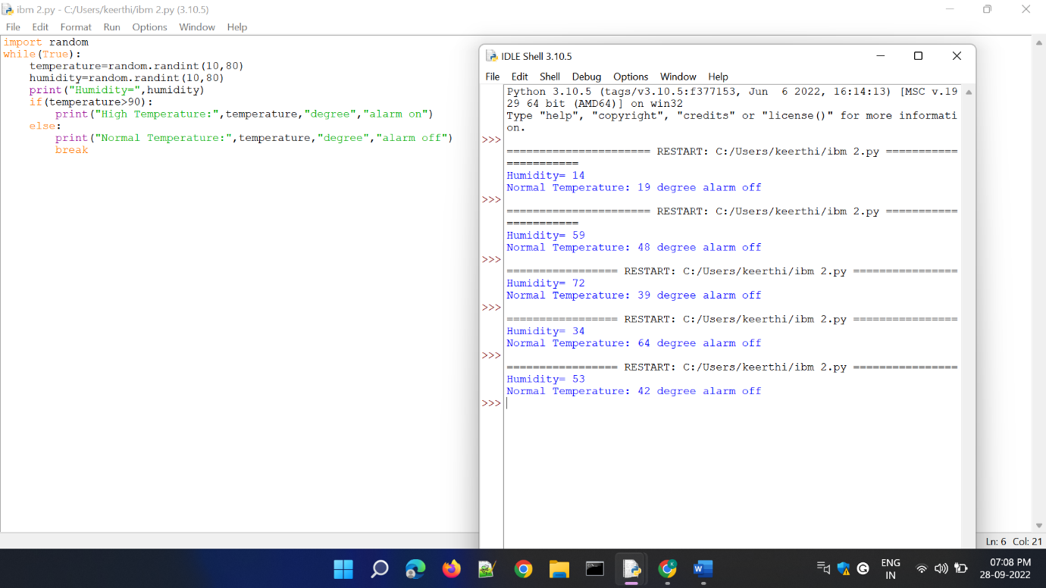

Program:

import random

while(True):

temperature=random.randint(10,80)

humidity=random.randint(10,80)

print("Humidity=",humidity)

if(temperature>35):

print("High Temperature:",temperature,"degree","alarm on")

else:

print("Normal Temperature:",temperature,"degree","alarm off")

break